CSCI 4390.01
Senior Project

Gold Palace Perfume Shop

Oscar Torres, Lazaro Vallejo, Eliud G. Cortes, and Juan Aguilar
oscar.torres01@utrgv.edu
lazaro.vallejo01@utrgv.edu
juan.c.aguilar02@utrgv.edu
eliud.cortes01@utrgv.edu

- Introduction
Problem Description:

Gold Palace Kosmos International is a store found in Downtown McAllen along Main Street. It is a store with hundreds of different kinds of perfumes and even a small assortment of jewelry. Gold Palace receives many customers, many asking if there is a website to view the stores catalog. This is because many of the customers come from Mexico and sometimes find that their product is not in stock. In their facebook page, Gold Palace receives comments asking for prices of certain products and, requiring a manual reply, there is rarely a response. Gold Palace lacks a website to display their perfume stock, prices, and provide purchasing and delivery options to its customers. The purpose of a Perfume Store website is to make a user-friendly interface to facilitate the purchase of perfumes a consumer would want to make without having to visit the store.
Background:

Gold Palace Kosmos International has had a website before. But it failed to be functional and, according to the owner, the website was not able to allow customers to purchase any product. The website went down and Gold Palace did not pursue e-commerce. However, Eliud Cortes mentioned that he was working in a group looking to develop a website but had yet to confirm what kind of website to make. The owner of Gold Palace saw the opportunity and told Cortes that he was in need of a website for his store. This is how the decision to make a website for Gold Palace came about.
Overview:

The initial idea for the new Gold Palace website was to make a basic website that would display all readily available stock for the Gold Palace shop located in McAllen, Tx. After several iterations of the project, the team came to the decision to add several other functions to the website. This is because the owner of Gold Palace is looking to have a payment option to order online and have perfume products shipped. This document will go through the design and implementation of a website and database that allows for an e-commerce store to function. The website must be able to store and manage perfume, customer, and purchase information in the database. The website must be able to present various forms of information to the customer and the admin depending on what is needed. There must be an integration of the Paypal API to allow the customer to make a purchase and have that purchase stored. This requires a database that has many kinds of tables storing information related to each other and done so in a way that all data can be accessed as needed.

- Database and Design
ER Diagram
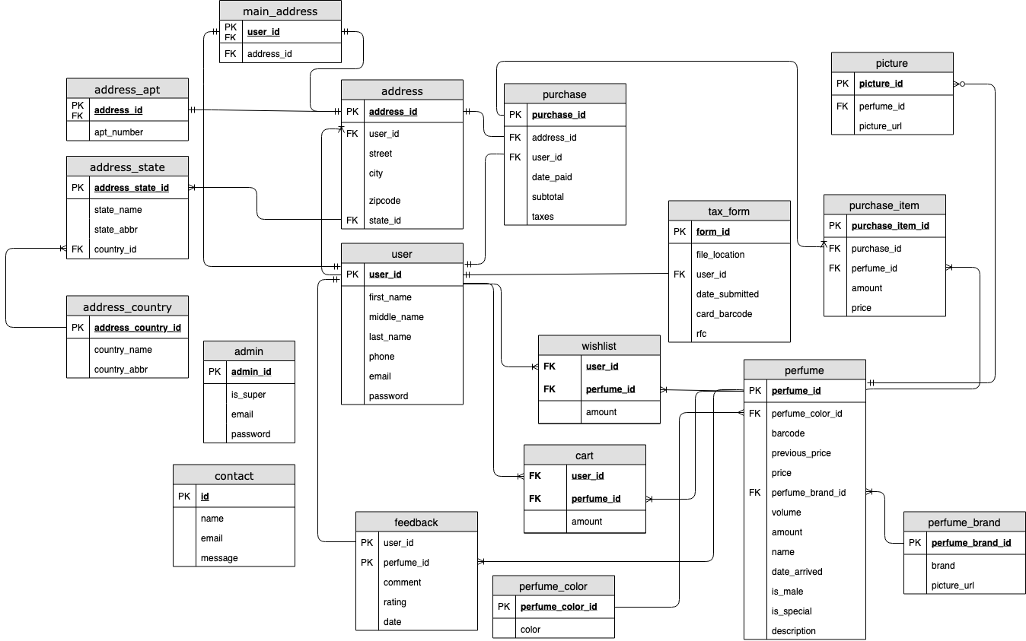

ER DIAGRAM
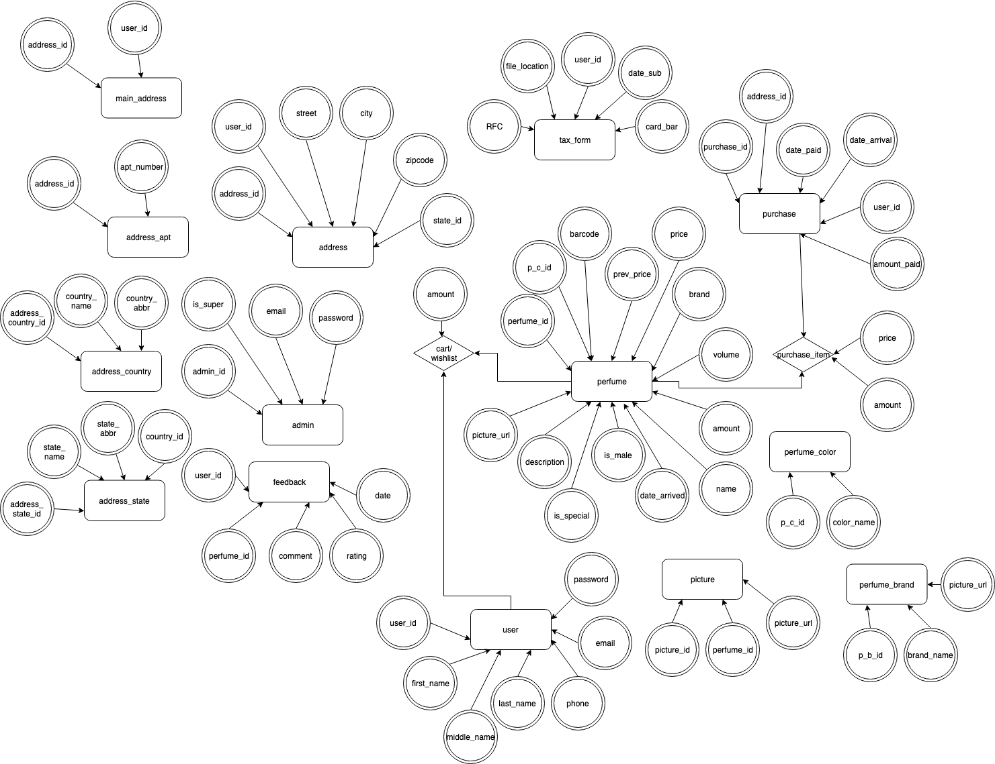

- TABLES:

Admin Table:
The Admin table holds information about an admin such as username and password. The table also has an attribute called is_super which is for future work: an admin can add more admins into the table if-and-only-if the admin is a super admin (is_super is set to 1/true). The admin can be uniquely identified with an id which is primary incremental key.
User Table:
The User table holds the information about a user. The table has basic login information such as email and password, and other information which can be used to contact the person and identify them, such as first, middle, and last name. The user can be uniquely identified with an id which is primary incremental key.
Perfume Table:
The perfume table holds information about each perfume in the store. It contains an auto-incrementing primary key which makes every tuple in the table unique and various other attributes to hold perfume information. It contains two attributes which are foreign keys: the perfume_color_id attribute and the perfume_brand_id attribute. The perfume_color_id is used to link the perfume table with the perfume color table. It is a one-to-many relationship where a color can belong to many different perfumes but one perfume can only have one color. The perfume_brand_id is used to link the perfume table with the perfume brand table. It is a one-to-many relationship where a brand can belong to many different perfumes but each perfume can only have one brand. The primary key perfume_id is used as a foreign key for various tables including the feedback, cart, wishlist, purchase item, and picture table. Each of these tables is related to perfume in a way and so must be included in each of its rows.
Perfume Brand Table:
The perfume brand table holds information about all the brands in the store. It is made up of an auto-incrementing key, perfume_brand_id, which makes every tuple in the table unique. The table also includes two more attributes. Brand is used to hold a string that is the name of the brand. Picture_url is used to hold the string url or destination of the picture that is of the brand. The primary key is used as a foreign key for the perfume table as perfume needs a brand.
Perfume Color Table:
The perfume color table holds information about all the colors of perfumes in the store. It is made up of an auto-incrementing key, perfume_color_id, which must make each color in the table unique. The table also includes another attribute. Color is used to hold a string of the name of the color. With the perfume color table, colors can be managed where new ones are added and old ones are deleted. The primary key is used as a foreign key for the perfume table as each perfume needs a color.
Purchase Table:
The purchase table holds information about each purchase that a user makes in the online store.It contains an auto-incrementing primary key, purchase_id, which makes each purchase unique. It contains five further attributes: address_id, user_id, date_paid, subtotal, taxes. The last three, respectively, hold information about the purchase such as when it occurred, the subtotal and the taxes paid. Address_id is a foreign key used to link the purchase table with the address table. It is a one-to-many relationship where an address can belong to multiple purchases but each purchase has only one address. This relationship is used to keep track of the address to which each purchase is related. User_id is a foreign key used to link the purchase table with the user table. It is a one-to-many relationship where a user can have many purchases but each purchase can only have one user. This relationship tells which user the purchase is related to. The primary key of the purchase table is a foreign key of the purchase item table. This is because each purchase_item belongs to one purchase. That is to say that purchase table is a representation of a purchase taking place and not each item purchased in the store. To view the items purchased, the purchase item table is needed.
Purchase Item Table:
The purchase item table holds the information of every item purchased in the online store by a user. It contains an auto-incrementing primary key, pruchase_item_id, which makes each purchase item unique. It contains four further attributes: purchase_id, perfume_id, amount, and price. The last two attributes, respectively, are used to store the quantity of said item purchased and the price at which it was done. Purchase_id is a foreign key used to link the purchase item table with the purchase table. It has a one-to-many relationship where a purchase can have several purchase items but each purchase item can only belong to one purchase. This relationship allows for the purchase item table to be queried so that only the purchase items that belong to a certain purchase are retrieved. However, this means that to retrieve a descriptive purchase, the whole of the purchase item table must be scanned to check if a purchase item has a perfume_id that matches the perfume_id of the purchase. Perfume_id is a foreign key used to link the perfume table with the purchase item table. It is a one-to-many relationship where a perfume can be in several different purchase items but each purchase item can only have one perfume. This relationship is to get the information of each purchase item which is a perfume.
Cart/Wishlist Table:
The cart and the wishlist table are identical in structure and store the information of items that users have added to the cart/wishlist table. They both are made up of three attributes: user_id, perfume_id, amount. The tables do not have a primary key as they instead use the foreign keys to keep order and make sure there are no duplicates in the table. User_id is used to link the cart/wishlist table to the user table. It is a one-to-many relationship where a cart/wishlist has one user but one user can have many of the cart/wishlist. This is because the information being stored in the cart/wishlist table is considered an item related to a user. It is recognized as being an item by perfume_id which is used to link the cart/wishlist table to the perfume table. This is a one-to-many relation. Amount is used to keep track of the quantity for a unique perfume that a user has added to the table. The tables are used for different things as the wishlist table is used to store the users future potential purchase. The cart table is used to store the user’s current potential purchase.
Picture Table:
The picture table holds information about every perfume picture used in the online store. Picture_id, its auto-incrementing key is used to make sure that each picture is unique. It contains two more attributes. Perfume_id is a foreign key used to link the picture table to the perfume table. It is a one-to-many relationship where a picture belongs to one perfume and a perfume can have many pictures. The picture_url is used to hold the destination of the picture which is used to get access to the picture.
Feedback Table:
The feedback table holds the information about every comment made by a user for a certain perfume. It has uses two foreign keys as its primary keys to keep their from ever being a duplicate response to a perfume. Comment, rating, and data are attributes used to store the data of the feedback such as the string that was entered by the user, the star rating chosen by the user, and the time at which the user entered the information. The user_id is a foreign key used to link the feedback table to the user table in a one to many relationship. Each feedback has one user but a user can write many feedbacks. The perfume_id is used to link the feedback table to perfume table in a one-to-many relationship where a feedback can be for only one user but a perfume can have many feedbacks. This means that for a feedback, there can be no more than one entry for a perfume by a user.
Contact Table:
The contact table hold the information about every message sent to the online store. It’s purpose is to store messages submitted by any kind of user. For this reason there is an auto-incrementing key call Id. The attributes name, email, and message are used to store the information for contact. The name of the sender, the email of the sender, and the message that the send wants to submit for the store. This data can then be managed by an admin to see that latest or delete any.
Tax Form Table:
The tax form table holds the information of a special information that a user can choose to submit to the online store. There is an auto-incrementing key, form_id, making each tax form unique. The attributes file_location, date_submitted, card_bardcode, and rtc are used to store the information of the tax form such as the file location of the document, the date submitted, etc. User_id is used to link the tax form table with the user table in a one-to-one relationship. For each user there is only one document and each document belongs to one user.
Address Table:
The address table holds the information of every address submitted by users to the online store. The auto-incrementing attribute, address_id, is used to make every row in the address table unique. The attributes street, city, and zipcode are used to store the information of an address as each stores what its name implies. User_id is a foreign key used to link the address table to the user table in a many-to-many relationship. Where an address can belong to many users and a user can have multiple addresses. State_id is a foreign key used to link the address to the address_state in one-to-many relation. Where a state can have many addresses and an address can have only one state. The primary key of the address table is used as a foreign key by the main address table and the address apt table.
Main Address Table:
The main address table is used to store the one address that a user has chosen to be their main address. The main address comes from the address table. Main address table has user_id and address_id. User_id is used to link the main address to the user table in a one to one relationship. A main address can have one user and a user can only have one main address. Address_id is a foreign key used to link the main address table to the address table. It is a one-to-many relationship. Where a main address can have only one address but an address by many main addresses.
Address Apt Table:
The address apt table is used to store the apartment number of the user if they have any. It is made up of address_id and apt_number. Apt_number is used to store the number if there is any. Addnress_id is used to link the address to the address apt table. The relation is a zero or one. Where there can be no address apt for the address or there is one address apt for the address.
Address State Table:
The address state table is used to store the information concerning the states in a table. It has an auto-incrementing key, address _state_id, used to make sure that each state is considered unique. State_name, and state_abbr to store the information of the state. County_id is used a foreign key used to link the address_country to the address state table. It is a one to many relation where a state has one country and a country has many states. Its primary key is used as a foreign key in the address table. This is to get the state information to the address.
Address Country Table:
The address country table is used to store the information of the country in the table. The address_country_id is an auto-incrementing key used to keep find each country. The attributes country_name and country_abbr are used to store the name of the country and the shorthand name. The primary key is a foreign in the address state key.

- MODELS:

The models are the primary interface to find and manipulate data in the database. The models were created with the use of Propel. Propel is an open-source Object-Relational Mapping(ORM) for SQL-Databases in PHP 5.5+. An ORM abstracts the database layer: it takes an XML file, the schema, and from it generates SQL and PHP classes with optimized code. All method calls used from each model will be documented and those methods not originally generated by Propel will be documented as well.

Admin Model:
The Admin Model is an used to find and manipulate data in the Admin table. It’s function is to be able to retrieve a row of information from the Admin Table, check and verify an incoming password with one in the Admin Table, create a session(server cookie) that holds the the Admin’s id, and constructs an instance of the Admin ORM that represents the row retrieved from the Admin Table.
findOneByEmail($email): Connects to the database and executes a mySQL query selecting a row by comparing the Admin attribute Email to $email. The first row to meet the condition is returned in the current query object and a termination method returns the result, an Admin object with the same email as $email.
hashPassword(): A SET query that updates the current Admin object with the condition to hash the password. Used after a password is set, hashPassword() takes the password from the current Admin object and hashes it with the PHP function password_hash( string $password , int $algo [, array $options ]). The new password is then set as the password for the current Admin object.
verifyPassword($password): Boolean method that returns true if $password is the correct one according to the current Admin object. PHP password_verify(string $password_hash, string $hash) takes the value $password and the hash from the current Admin object. $password is hashed and if it equals the hash, it returns true. False, otherwise.
logIn(): Starts a session with the current Admin object’s Id.
logOut(): Ends a session.
current(): Starts a session and returns the user that is currently logged in. It does so by checking if there is a session in progress and returning a User object by the primary key found in the session.
User Model:
The User Model is an used to find and manipulate data in the User table. It’s function is to be able to retrieve a row of information from the User Table, check and verify an incoming password with one in the User Table, create a session(server cookie) that holds the the User’s id, and constructs an instance of the User ORM that represents the row retrieved from the User Table.
findOneByEmail($email): Connects to the database and executes a mySQL query selecting a row by comparing the User attribute Email to $email. The first row to meet the condition is returned in the current query object and a termination method returns the result, a User object with the same email as $email.
hashPassword(): A SET query that updates the current User object with the condition to hash the password. Used after a password is set, hashPassword() takes the password from the current User object and hashes it with the PHP function password_hash( string $password , int $algo [, array $options ]). The new password is then set as the password for the current User object.
verifyPassword($password): Boolean method that returns true if $password is the correct one according to the current User object. PHP password_verify(string $password_hash, string $hash) takes the value $password and the hash from the current User object. $password is hashed and if it equals the hash, it returns true. False, otherwise.
setByName($name,$str,$type = TableMap::TYPE_PHPNAME): Method working on one User object. A $str that is an empty string is set to null and if there are any ‘_’ they are removed and the next character, if any, is capitalized. $name is then set as the name of the User object.
getPurchases(): A method used to deal with the one to many relationship between the user table and the purchase table. The method returns a collection of Purchases objects that have a foreign key user_id equal to the primary key user_id in the current User object.
getFullName(): A getter method that first concatenates a firstName, middleName, and lastName from the current User object. The new name is then returned as a string.
logIn(): Starts a session with the current Admin object’s Id.
logOut(): Ends a session.
current(): Starts a session and returns the user that is currently logged in. It does so by checking if there is a session in progress and returning a User object by the primary key found in the session.

Perfume Model:
The Perfume Model is used to find and manipulate data in the Perfume. It contains methods that were not created by Propel’s build. It’s function is to be able to retrieve a Perfume object, or multiple, containing a row of information from the Perfume table. The methods found in the perfume model also interact with the querying methods in other models as there is information pertaining to perfumes found in other tables.
findOneByPerfumeId($id): Connects to the database and executes a mySQL query selecting a row by comparing each Perfume attribute Id to $id. The first row to meet the condition is returned in the current query object and a termination method returns the result, a Perfume object with the same id as $id.
filterByPerfumeId($id):Connects to the database and executes a mySQL query selecting rows by comparing each Perfume attribute Id to $id. The comparison is to check if the $Id value is equal to Id. The method returns every row to meet the condition as a collection of query Perfume objects. The collection can be further augmented by other connections such as sorting the objects by a certain attribute. Otherwise, a find() method is used to terminate the process and return the results.
filterByNameSubString($search): Connects to the database and executes a mySQL query selecting rows by comparing each Perfume attribute name to $search. The comparison is to check if the $search value is a substring of the Perfume attribute name. The method returns every row to meet the condition as a collection of query Perfume objects. The collection can be further augmented by other connections such as sorting the objects by a certain attribute. Otherwise, a find() method is used to terminate the process and return the results.
filterByVolumeBetween($value1, $value2):Connects to the database and executes a mySQL query selecting rows by comparing each Perfume attribute volume to $value1 and $value2. The comparison is to check if the $value1 value is less than the value of the Perfume attribute volume and for $value2 to be greater than volume. This is done by using ->where in SQL code. The method returns every row to meet the condition as a collection of query Perfume objects. The collection can be further augmented by other connections such as sorting the objects by a certain attribute. Otherwise, a find() method is used to terminate the process and return the results.
filterByPriceBetween($begin, $end):Connects to the database and executes a mySQL query selecting rows by comparing each Perfume attribute price to $begin and $end. The comparison is to check if the $begin value is a less than the value of price and that $end is greater than the value of price. Using SQL, the Perfumes that are between a certain price can be found. The method returns every row to meet the condition as a collection of query Perfume objects. The collection can be further augmented by other connections such as sorting the objects by a certain attribute. Otherwise, a find() method is used to terminate the process and return the results.
orderByName(): A query method to handle a collection of Perfume objects. It orders the Perfume objects by their attribute name in a descending order. The method uses the SQL statement order to carry out the process. The find() method can then be used to return the ordered objects.
usePerfumeBrandQuery(): Connects to the database and executes a mySQL query to perform a left join query on the Perfume Table and the Perfume Brand Table. With the new query table, it can then be handled by Perfume Brand Model query methods such as to filter the collection of Perfume objects or to order them. Once there is no more use for the Perfume Brand methods, an end() method is used to have the query table only keep the Perfume Table attributes. Find() then terminates the process and returns the collection of Perfume objects.
usePerfumeColorQuery(): Connects to the database and executes a mySQL query to perform a left join query on the Perfume Table and the Perfume Color Table. With the new query table, it can then be handled by Perfume Color Model query methods such as to filter the collection of Perfume objects or to order them. Once there is no more use for the Perfume Color methods, an end() method is used to have the query table only keep the Perfume Table attributes. Find() then terminates the process and returns the collection of Perfume objects.
setDateArrived($time): A set method workin on one Perfume object. $time is a DATETIME attribute that is to be stored in the attribute date_arrived. Date_arrived is a DATE type.
setPerfumeXXX($value): All the set methods used to manage the data in the Perfume table. It can be used to set a new Perfume object which can then be saved to the perfume table. Or take a row from the perfume table as a Perfume object and then edit the attributes in that object to save them to the table.
setByName():($name,$str,$type = TableMap::TYPE_PHPNAME): Method working on one Perfume object. A $str that is an empty string is set to null and if there are any ‘_’ they are removed and the next character, if any, is capitalized. $name is then set as the name of the User object t.
getShortName($length = null): A method that handles one Perfume object. It takes the name of the Perfume object and get a length from it. It then compares the length of the name with the value of $length. If the value is greater than, it will get a substring of the name down to the size of $length and concatenate the string “...”. This is done to present the website with a name that will fit in its destination.
getFromItems($items, $user): A query method to left join the perfume, cart, and picture table into one query table. The attribute of cart is amount and is renamed quantity. The attribute of picture is pictureurl and is renamed pictureUrl in the new query table. $items is collection of perfume objects and each has an id that is stored in an array that is used to find all rows which have a perfume id found in the array. This query table is a collection of a new kind of objects and is returned.

Perfume Brand Model:
The Perfume Brand Model is used to find and manipulate data in the Perfume Brand table. It contains methods that were not created by Propel’s build. It’s function is to be able to retrieve a Perfume Brand object, or multiple, containing a row of information from the Perfume table. The methods found in the perfume model also interact with the querying methods in other models as there is information pertaining to perfumes found in other tables.
orderByBrandName(): A query method to handle a collection of Brand objects. It orders the Brand objects by their attribute ‘brand’ in a descending order. The method uses the SQL statement order to carry out the process. The find() method can then be used to return the ordered objects.
filterByBrandNameSubString($search): Connects to the database and executes a mySQL query selecting rows by comparing each Perfume Brand attribute ‘brand’ to $search. The comparison is to check if the $search value is a substring of the Perfume Brand attribute ‘brand’. The method returns every row to meet the condition as a collection of query Perfume Brand objects. The collection can be further augmented by other connections such as sorting the objects by a certain attribute. Otherwise, a find() method is used to terminate the process and return the results.

Perfume Color Model:
The Perfume Color Model is used to find and manipulate data in the Perfume Color table. It contains methods that were not created by Propel’s build. It’s function is to be able to retrieve a Perfume Color object, or multiple, containing a row of information from the Perfume Brand table. The methods found in the perfume brand model also interact with the querying methods in other models as there is information pertaining to perfumes found in other tables.
filterByColorName($colorname): Connects to the database and executes a mySQL query selecting rows by comparing each Perfume Color attribute ‘color’ to $colorname. The comparison is to check if the $colorname value is equal to ‘color’. The method returns every row to meet the condition as a collection of query Perfume Color objects. The collection can be further augmented by other connections such as sorting the objects by a certain attribute. Otherwise, a find() method is used to terminate the process and return the results.
Purchase Model:
The Purchase Model is used to find and manipulate data in the Purchase table. It contains methods that were not created by Propel’s build. It’s function is to be able to retrieve a Purchase object, or multiple, containing a row of information from pertaining to the purchases that a user has made. The methods found in the purchase model also interact with the querying methods in other models as there is information pertaining to perfumes found in other tables.
filterByUserId($id): Connects to the database and executes a mySQL query selecting rows by comparing each Purchase attribute user_id to $id. The comparison is to check if the $Id value is equal to user_id in a row in the purchase table. The method returns every row to meet the condition as a collection of query purchase objects. The collection can be further augmented by other connections such as sorting the objects by a certain attribute. Otherwise, a find() method is used to terminate the process and return the results.
filteryByUser($user): A method that takes a user object in its parameter. It connects to the database and executes a mySQL query selecting rows by comparing the primary key of $user to the identical attribute found in the purchase table. The method returns every row to meet the condition as a collection of query purchase objects. The collection can be further augmented and if not find() ends it. The filterByUser is implemented as an alternative to taking a primary key from a user object and implementing the filterByUserId method.
findOneByPurchaseId($id): Connects to database, executes mySQL to return a purchase object set with the data from the row in the purchase table that met the conditions. The condition being that the row must have an attribute purchase_id that matches $id from the parameter. This method finds the first row to meet the condition and in a table where each row is unique instance of a purchase, it is all that is needed. Once the row is found, the data is returned as an instance of a purchase object.
getPurchaseItems():A method used to deal with the one to many relationship between the purchase table and the purchase item table. The method returns a collection of Purchase item objects that have a foreign key purchae_id equal to the primary key purchase_id in the current purchase object.
setUp($perfumes, $user, $amount): A method to be used when a purchase is carried out. A purchase requires there to be a perfume, a user, an amount that was indicated in the webpage. Using $user, a user object, the main address object is obtained using $user->getMainAddress(). Then ->getAddressId() gets the id from the main address which is used to set the AddressId of the current purchase object. The current purchase object’s user_id are set with the primary key from $user. The attribute datePaid is set by the time at which the purchase was made. The subtotal is set by $amount, an array containing to values: the value used pertains to subtotal. Taxes are set by the value pertaining to taxes in $amount. $perfumes is a collection of perfume objects. For each perfume, a purchase item object is made that is set. The perfume attribute of the purchase item object is set by the identical attribute in the current perfume in the loop. Amount attribute is set by the quantity found in the current perfume loop(the perfume object has a quantity as getFromItems creates a perfume object joined with cart and picture). Price is set just as amount is. The purchase attribute is set by the primary key of the current purchase object.

Purchase Item Model:
getPerfume(): Returns the perfume object that the current purche item project is related to with a primary key. That is, using the foreign key in purchase item, a purchase object is retrieved with the primary key that equals it.
getAmount(): The value in attribute amount is retrieved from the current purchase item object.
Cart Model:
filterByCartPerfume($perfume): Retrieves a collection of cart objects from the cart table that have a foreign key perfume id equal to the primary key of $perfume.
filterByCartUser($user): Retrieves a collection of cart objects from the cart table that have a foreign key user id equal to the primary key of $user.
filterByUserId($id): Retrieves a collection of cart object from the cart table that has an attribute user id that is equal to $id.
filterByPerfumeId($id): Retrieves a collection of cart objects from the cart table that has an attribute perfume id that is equal to $id.
setXXX($value): set methods used to store data in the cart table.
Wishlist Model:
filterByUserId($id): Retrieve a collection of wishlist objects from the wishlist table that has an attribute user id that is equal to $id.
filterByPerfumeId($id): Retrieve a collection of wishlist objects form the wishlist table that has an attribute perfume id that is equal to $id.
setXXX($value): set methods used to store data in the wishlist table.
Picture Model:
findByPerfume($perfume): A method that takes a perfume object in its parameter. By comparing the primary key of $perfume to the identical attribute found in the picture table, a collection of picture objects is returned.
findOneByPictureId($id): Method that returns one row from the picture table as a picture object. The row in picture table must have an attribute picture id that is equal to $id. Serves to retrieve a picture by using the foreign key picture id found in a perfume object.
Feedback Model:
filtyerByUser($user): A method that takes a user object in its parameter. By comparing the primary key of $user to the identical attribute found in the feedback table, a collection of feedback objects is returned.
filterByPerfume($perfume): A method that takes a perfume object in its parameter. By comparing the primary key of $perfume to the identical attribute found in the feedback table, a collection of feedback objects is returned.
filtyerByPerfumeId($id): Retrieve a collection of wishlist objects form the wishlist table that has an attribute perfume id that is equal to $id.

Contact Model:
Methods are used inside the view files and not the controller files.

Tax Form Model:
As the tax form is never implemented in the website, there is no method from the tax form model that is used. The tax form is an aspect that the website never implements.
Address Model:
Main Address Model:
The Main Address Model is used to find and manipulate data in the Main Address table. It’s function is to be able to retrieve a Main Address object, or multiple, containing a row of information from the Main Address table. A user has multiple addresses, but can only have one main address.
getAddress(): A query method to get the Address associated by address id.
getUser(): A query method to get the User associated by user id.

Address Apt Model:
The Address Apt Model is used to find and manipulate data in the Address Apt table. It’s function is to be able to retrieve a Address State object, or multiple, containing a row of information from the Address Apt table.
getAddress(): A query method to get the Address associated by address id.

Address State Model:
The Address State Model is used to find and manipulate data in the Address State table. It’s function is to be able to retrieve a Address State object, or multiple, containing a row of information from the Address State table.
getAddressCountry(): A query method to get the Address Country associated by address country id.
getAddresses(): A query method to get all address associated by id from the address table.

Address Country Model:
The Address Country Model is used to find and manipulate data in the Address Country table. It’s function is to be able to retrieve a Address Country object, or multiple, containing a row of information from the Address Country table.
getAddress(): A query method to get the Address associated by address id.

- System Design
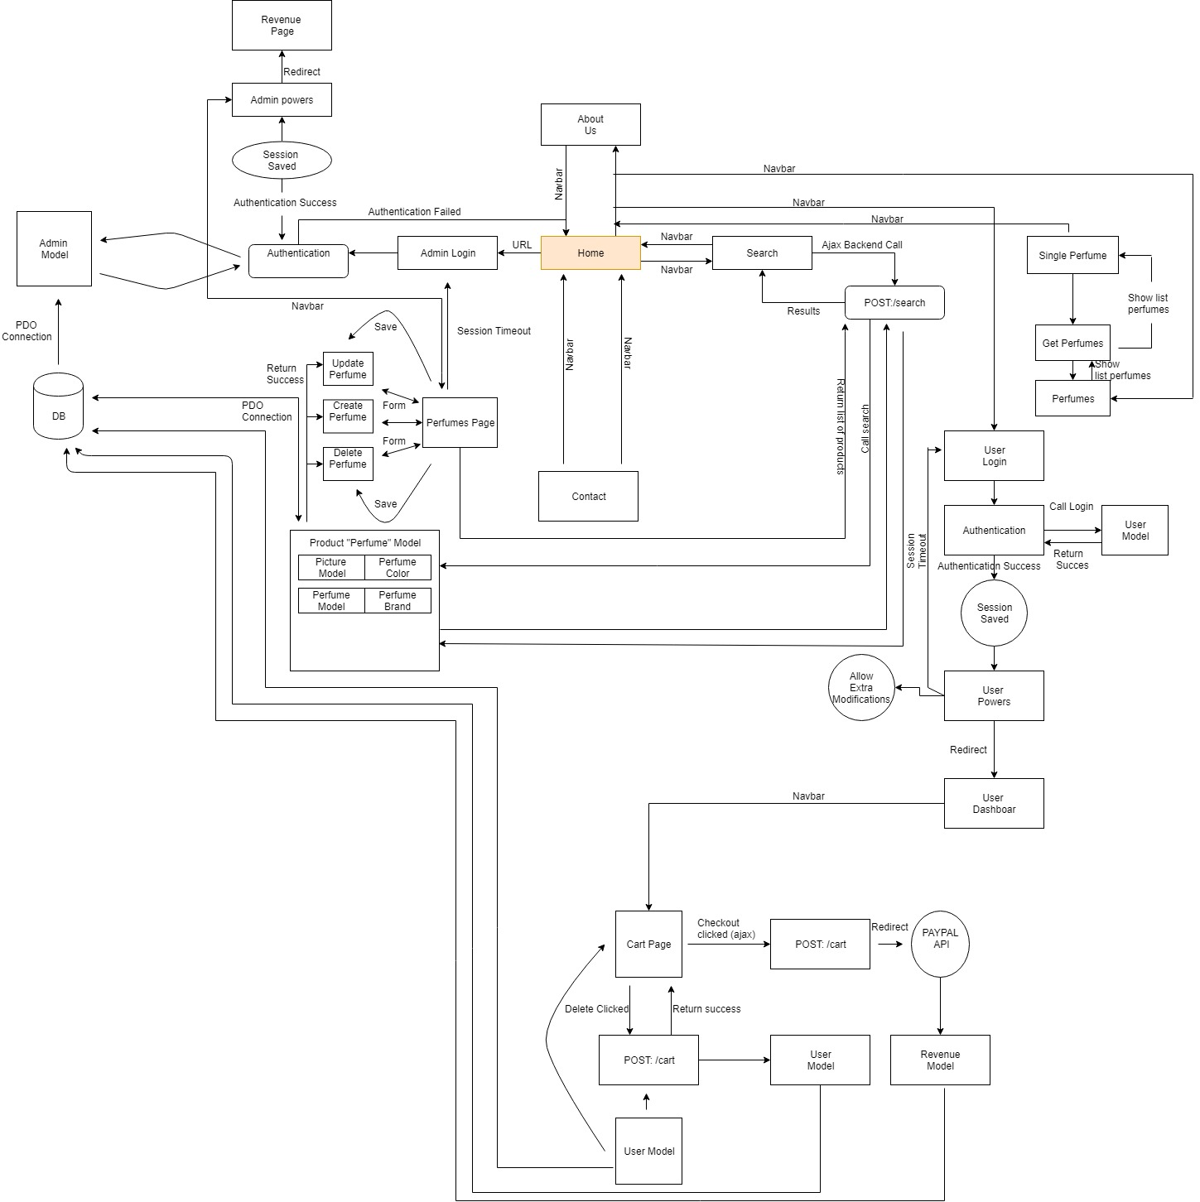

- Routes/Controllers

The controllers “control” what pages can be seen based on assigned rules.
Admin Routes:
Only users logged in as Admins can view these routes:
GET: ‘/admin/perfumes’
Show a list of perfumes and all their information in a table.
POST: ‘/add-perfume’
Add a perfume, the post parameters consist ‘Perfume[]’, ‘brand’ , and ‘color’.
POST: ‘/add-picture’
Add picture for perfumes using Uppy file uploader. The post parameters consist of ‘id’, which is the perfume id that pictures are being added to.
POST: ‘/ajax-pictures’
Returns a list of pictures for a perfume. This is needed when loading different pictures for different perfumes without loading them all at the same time. The post parameters consist of ‘id’ or ‘perfume-id’
POST: ‘/delete-picture’
Deletes a picture from a perfume. Used with AJAX since pictures are loading dynamically (from ajax-pictures above). The post parameters consist of ‘id’, which connects to the picture table (id field)

User Routes:
Only logged in Users can view these routes:
GET: ‘account’
The user can see their main information in this page. They can see information such as main address, their profile picture, and their name
GET: ‘/account/orders’
The user can view their order history here, in less detail than the route below.
GET: ‘/account/order/{id}’
The user can view order details here for a specific order, more detailed than the above route. The parameter {id} links to the id of the order table.
GET: ‘account/addresses'
The user can view all their addresses here, but can’t edit (update) due to the way reporting is done. The user can also add an address if they choose to.
GET: ‘/account/change-password’
The user can view the form to change their password.
POST: ‘/account/change-password’
The user posts to this route from the route above. The user needs to verify their password in the first field, and type their new password in the second. Both values are passed as post parameters.
POST: ‘/perfume-rating’
The user can post reviews for a perfume, and can only post one review per perfume. The post parameters are ‘id’, which links to a perfume by its id, ‘rating’, which has a value from 1 to 5, and ‘comment’ which is text that the user prefers post for that perfume.
GET: ‘/reset-password’
The user can view the form to reset their password. User must input email.
POST: ‘/reset-password’
The user can post their information here from the previous route (GET: reset-password). The current email is verified and an email is sent to the user with a special hash.
GET: ‘/cart’
The user can view their cart. The cart consist of a perfume (its information) and an amount (how much of that perfume was added to card).
GET: ‘wishlist’
The user can view their wishlist. The wishlist perfumes can move to ‘/card’ through a post button.
GET: ‘/checkout’
The user can checkout to paypal. The perfumes are viewed here before proceeding to payment.
GET: ‘user-logout’
User is redirected here to log out (Session is cleared).

All Routes:
Only logged in Users can view these routes:
GET: ‘/’
This is the home page. Different perfumes and brands are shown here. It is incomplete.
GET: ‘/perfumes’
All perfumes are displayed here. Special offers have a label on the top left (previous price < price)
GET: ‘/perfumes/byname’
Perfumes that have the name ‘byname’ are shown.
GET: ‘/perfumes/bybrand’
Perfumes that have the brand ‘bybrand’ are shown.
GET: ‘/perfumes/{color}’
Perfumes that have the color ‘color’ are shown.
GET: ‘/perfumes/oz/{number}/{numbertwo}’
Perfumes that have the volume between number and numbertwo are shown (number >= volume >= numbertwo)
GET: ‘/perfumes/price/{number}/{numbertwo}’
Perfumes that have the price between number and numbertwo are shown (number >= price >= numbertwo)
GET: ‘/perfumes/bysearch/{string}’
Perfumes are queried based on a wildcard LIKE search. Perfumes who contain ‘string’ in their name or description are shown.
GET: ‘/perfume/{id}’
View perfume based on the ‘id’ parameter (links to perfume table). Shows perfume information such as reviews, description, name, and price.
GET: ‘/contact’
View contact form to ask question or report errors.
POST: ‘/contact’
Post to send email to us.
GET: ‘/about’
Show information about store.
POST: ‘/wishlist’
Post here to add a perfume to wishlist. Post parameters consist ‘id’ which connects to perfume table.
GET: ‘/pay-go’
This is called when a use checks out. Paypal API is called and a list of perfumes is sent to Paypal (perfumes from user cart).
GET: ‘/purchase[/{id}]’
This is the callback from Paypal. Paypal returns JSON with information pertaining to the transaction. If successful, the cart items are moved to the order table. Otherwise, nothing happens.

- Implementation
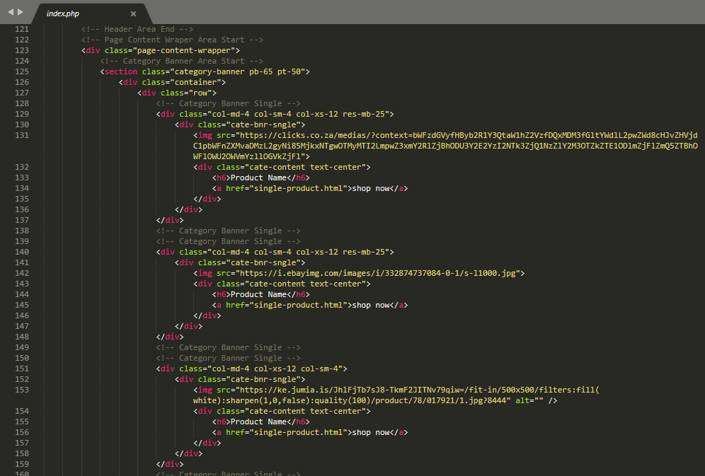
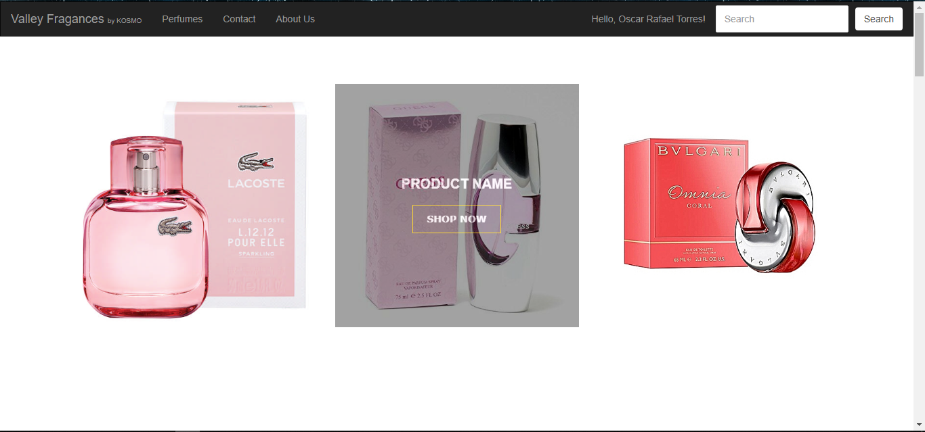

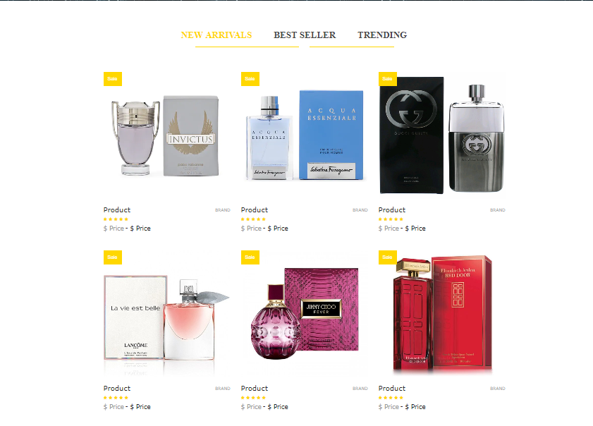
In the homepage the customer will be able to look at a few products before going into the products page where they will be able to look at all the products. Here we will show ‘New Arrivals’, ‘Best Seller’, and the ‘Trending’ perfumes which will be the most popular ones. There is also a Navigation Bar that is located in all of the pages where the user has access to every feature of the page, like their account, contact page, about us page, etc. The Navbar also has a Search form which will allow them to look for a perfume without having to browse through the variety of perfumes available which will make it easier and faster for them to find it.

PRODUCTS PAGE
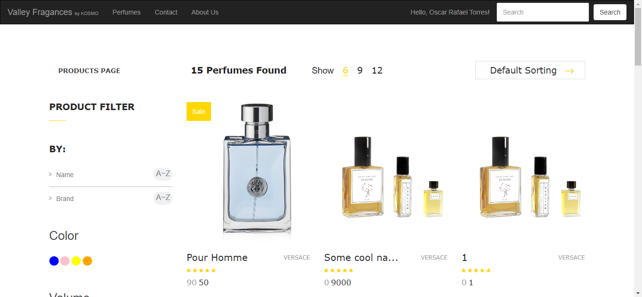
The products page will basically be the catalog page where all the perfumes available will be shown and the user will be able to filter by ‘name’, ‘brand’, ‘volume’, ‘color’. The user will also be able to select how many items by page you would like to show. If you decide to search for a perfume using the ‘Search’ function in the navbar this is the page that will also appear but showing the perfumes related to your search. Here is a couple of code lines
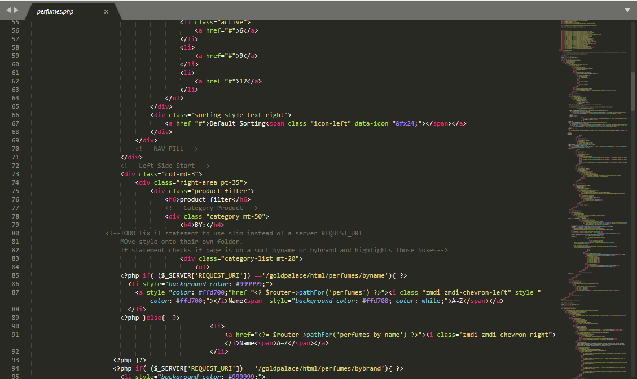
REGISTER PAGE
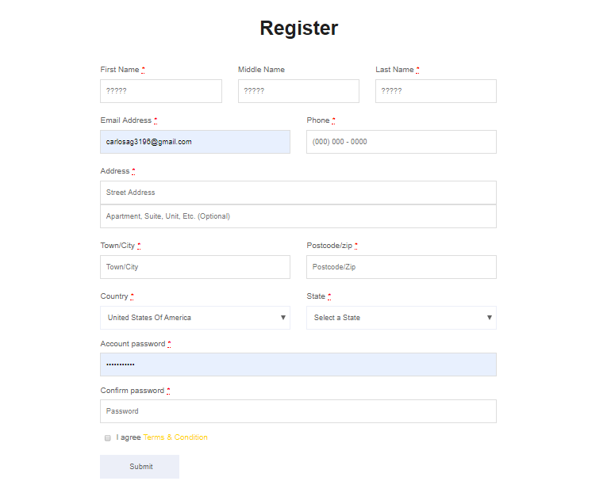
On this page the user will be able to register to create an account so that he/she can add perfumes to their wishlist, cart, make purchases, and have their addresses ready so that when the delivery needs to be made the store owners don’t have any trouble knowing where to send it. Here is a snippet of the code:
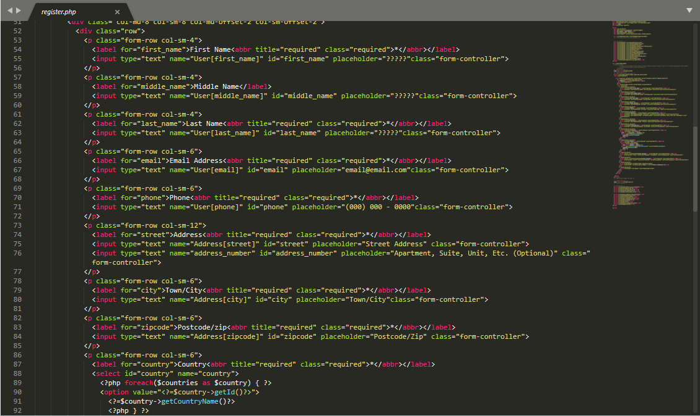

LOGIN / ACCOUNT PAGE
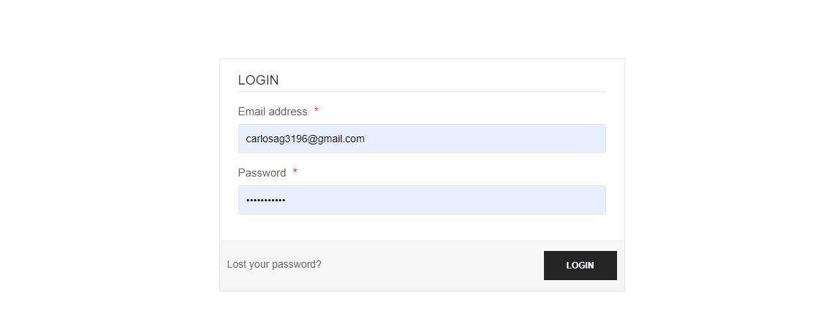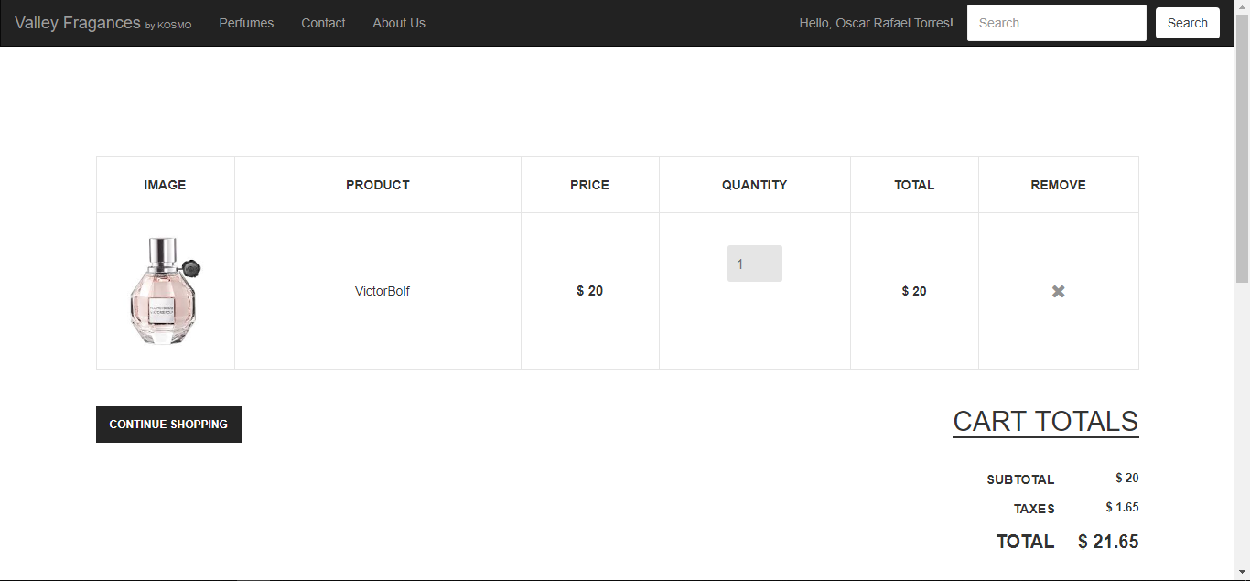
From the CART PAGE, the user can check out all the items in their cart and will be redirected to PayPal.
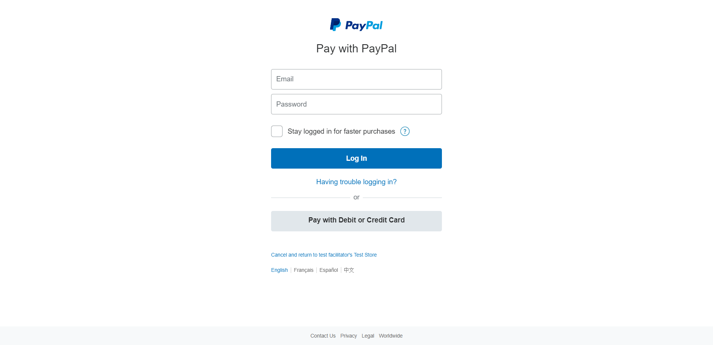

Code to call PayPal API: | Code to get the PayPal API result:
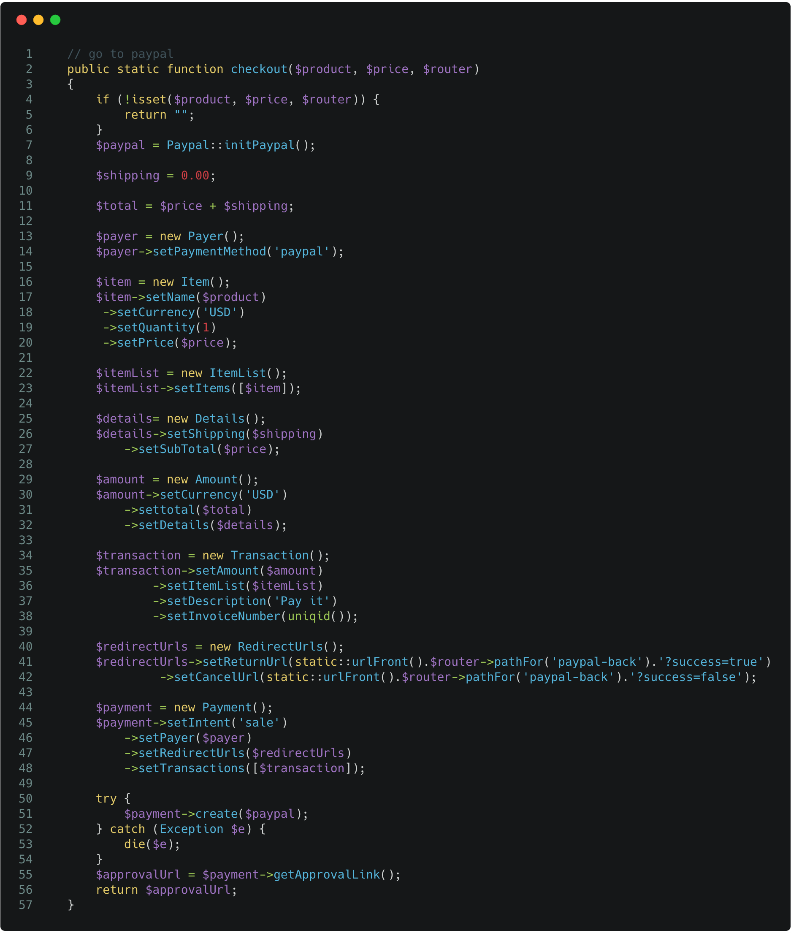 | 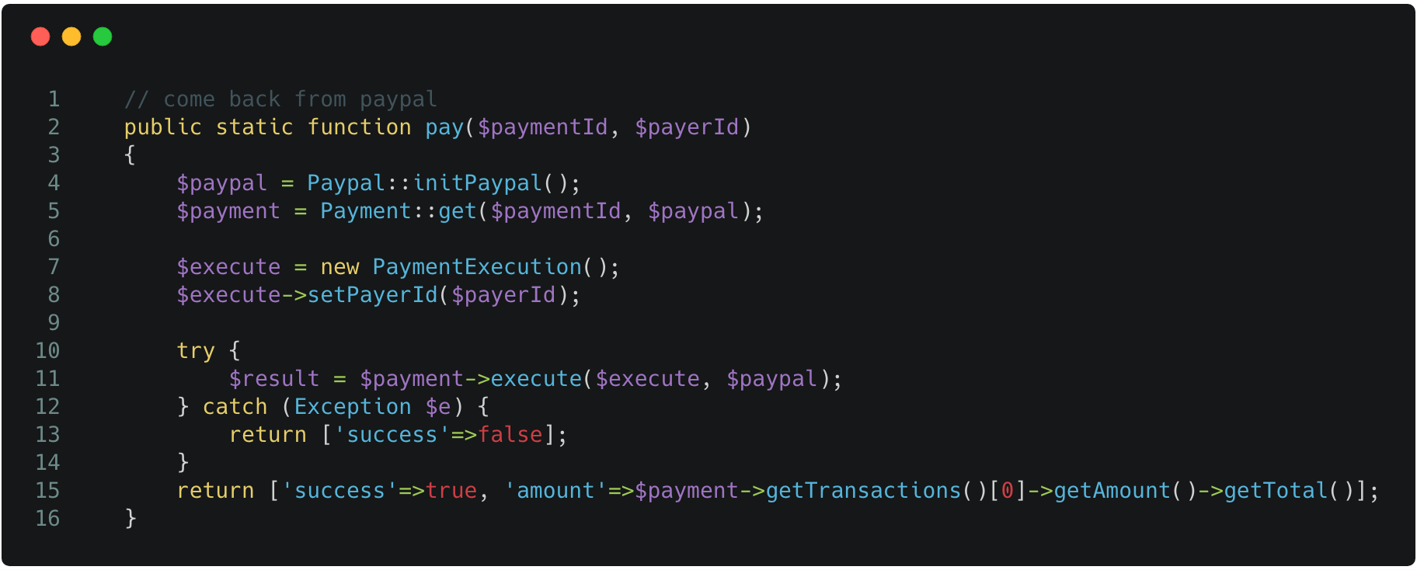

After confirming the payment, the user will be redirected back to the checkout page and will be greeted with a message stating the receipt of the transaction

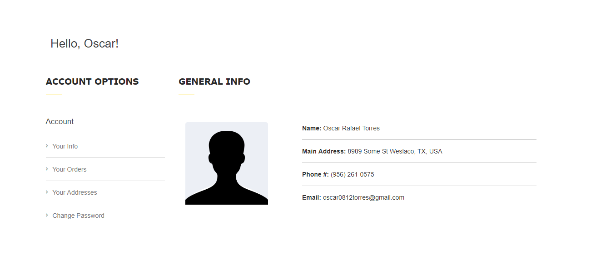
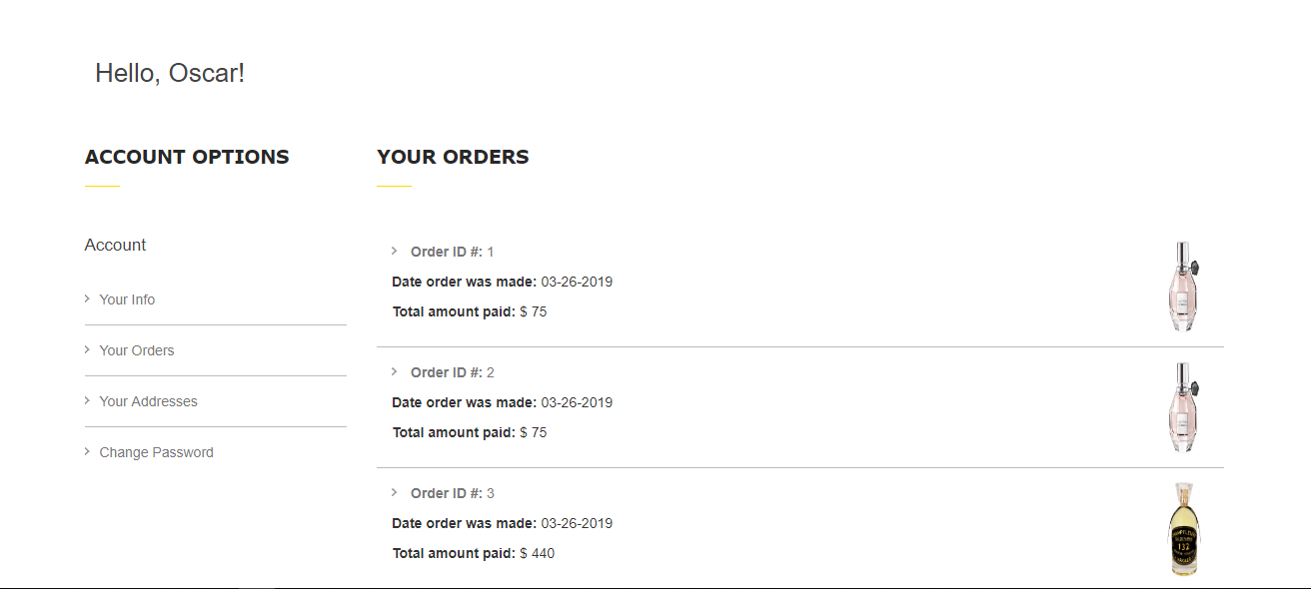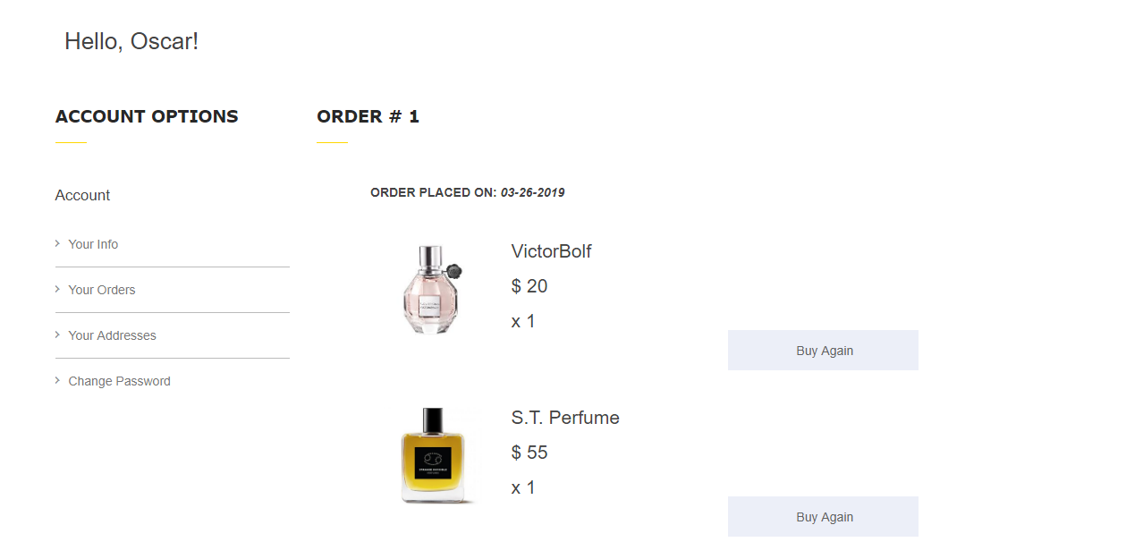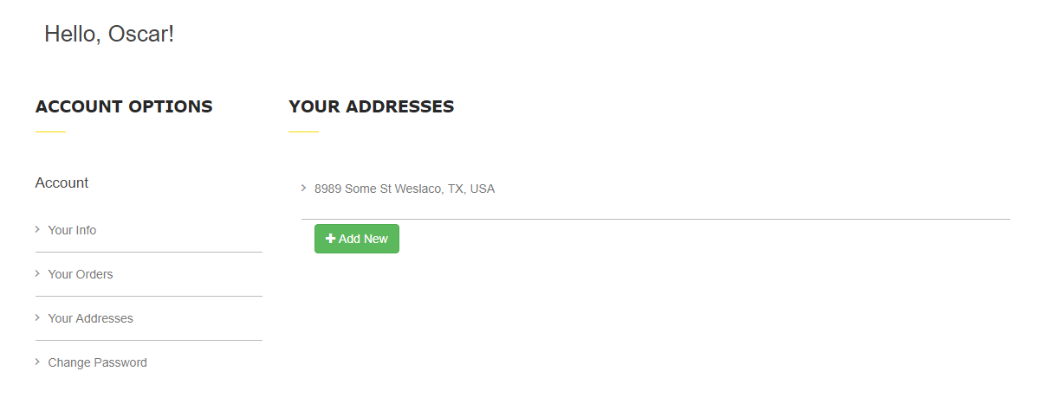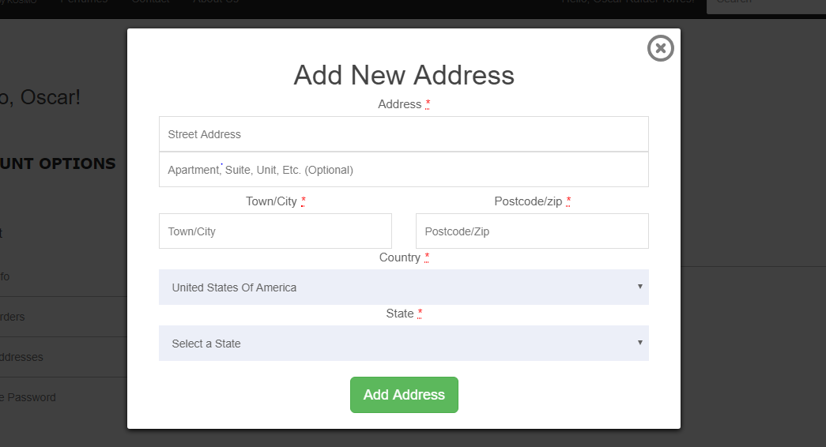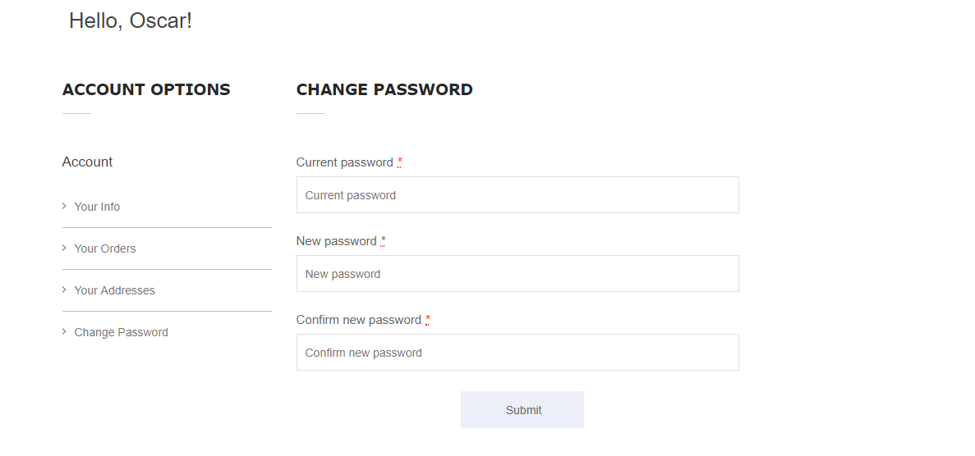
On this page we have the login page and all of the options for the user account. The user can mess with their account by adding new addresses, looking at their shopping cart or wishlist, changing their password, looking at their previous purchases and their general info. They can also include a picture of themselves if they wish to do so.

ADMIN PAGE
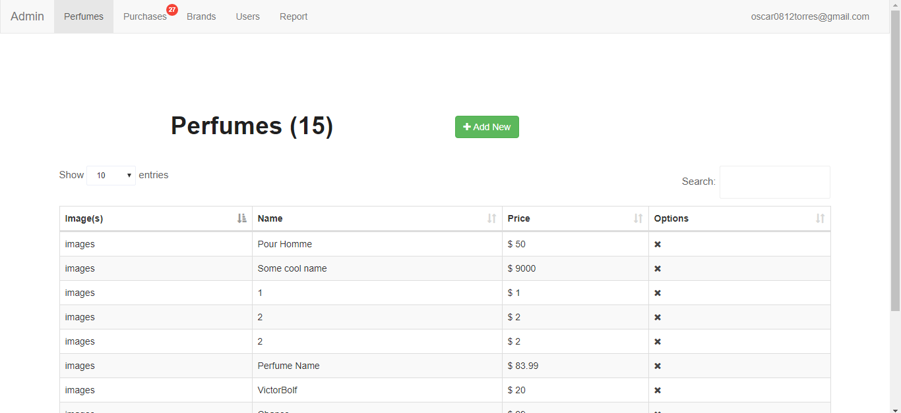

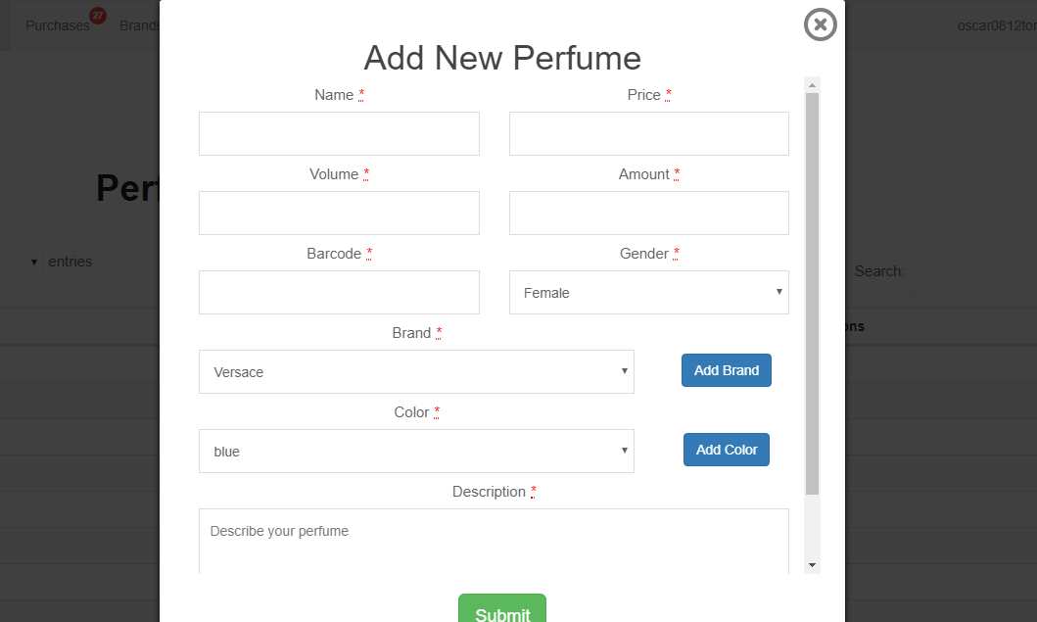
On the admin page you can input new products by using a form, it is a very simple way to mess with the database without having to actually mess with it on /phpmyadmin. This makes it easier for the owner to add products since he might not be familiarized with php or how to work a database.

CONTACT / ABOUT US PAGE
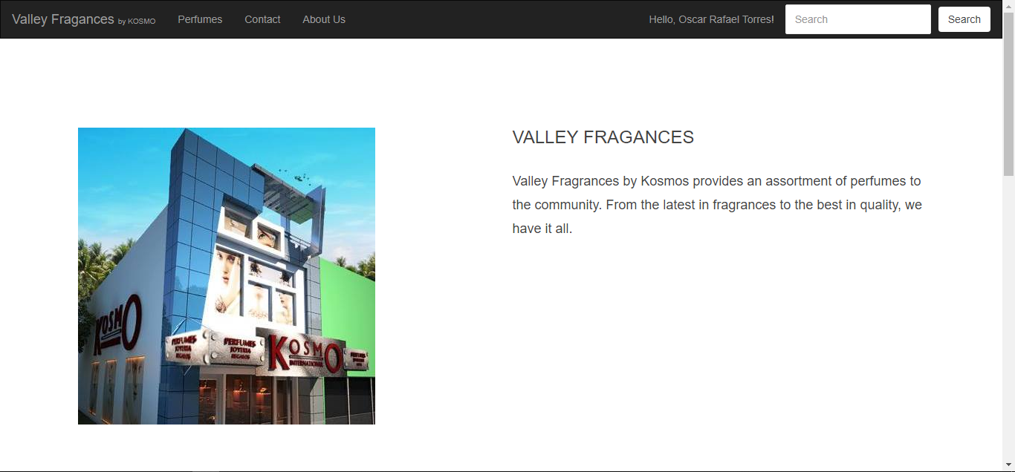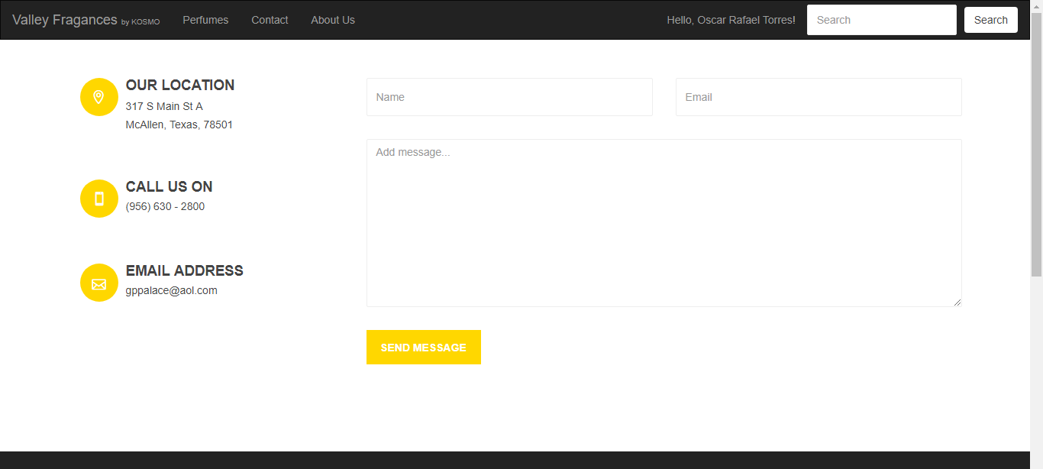
For the contact and about us page is very simple. Our info in one of them and with the contact page you have the option to send an email.

Usability:
The usability of the website is extremely simple and easy to navigate, any user or guest to the website would be able to find their way throughout the website to find what it is they are looking for. The user should find the experience with the site to be quite enjoyable as they move from page to page with fluidity and without having to load too many pages in the process either. Ajax was used to call the backend which would then send back information in JSON format so that there would be no reloading of the page. Overall, the website should be easy to use for the average user.

Testing:
Over the course of the development of the database and website, there has been testing on how each page of the website reacts with the database. Every page on the website queries the database for specific information that is relevant to the specific page. For example, when the user accesses the perfume page, the database receives a query to display all currently available perfumes in the order that they were added, as a result the user will then see a page loaded with the various perfumes that are currently populating the database. The testing of each page was done thoroughly in order to ensure that all relevant information regarding a specific page was displayed correctly and was easy to navigate through.
Contributions
Oscar Torres:
  - Database Developer/Designer
Took point on implementing the SQL and PHP that was required to communicate with the database from the initial site. Deployed the database and populated the database with the tables that later spawned the models for each respective part of the site. Lead the design of the new database and oversaw the overall progress of the database.

  - Front End Developer
Programmed the basic functions of several of the pages, such as Admin, User, Cart, Wishlist, and Address models. Took charge of the overall development and changes of the front end layout. Worked on various aspects of the website as where it was needed. Connectec the database to the paypal pages to carry out orders. Implemented a way to take pictures and store them for later use.

  - Back End Developer
Lead the development of the back end of the site, helped team members along in order to achieve the final result of a website with full functionality, not limited to sessions, a user cart for purchases, and PayPal functionality.
Lazaro Vallejo:
  - Database Designer
Helped Oscar design the database and decide how to implement it. Worked on facilitating the communication between the ORM’s and the database.
  - Front End Developer/Designer
Designed several different models and implemented the AJAX calls that helped facilitate communication with the database. Added the Slim implementation as well as the CSS styling to the web pages for cosmetic purposes. Designed the perfume page with search functionality and worked on getting users comments in the perfume-single page.
  - Back End Designer
Did extensive work on several of the views to facilitate the transition between each page on the website. Worked on the various models that came with Propel. Worked on connecting the perfume page with the backend models and querying based on search relevance. As well as with comments.
Juan Aguilar:
- Front End Designer
Created the Front End of Account and some connections to the backend models. Went through most views and modified as seemed fit.
- Back End Developer
Used the models and tables to carry out the Account tasks for Users

Eliud G. Cortes:
- Front End Designer
Focused on learning what was needed to carry out the work that was given. Spent most of the time learning and trying to set up the tools needed to work on the project.
- Other
Introduced us to Gold Palace shop owner. Worked on the system design for the document.

Conclusion
To conclude, the project was an overall success, the team worked tirelessly to meet the deadline and overcome many of the hurdles to accomplish the amount fully of functional components on the website. The new website for Gold Palace International Kosmos will be live and ready to be visited by users and readily available for the administrator to use at valleyfragrances.com. The website still needs much work for it to be fully practical in use. There is an implementation of counterpoint and shipping that must be taken care of.
Future Work
We were unable to completely integrate the web application with the store. This was due to the lack of communication. The store owner travels frequently and wasn’t able to meet much. Due to this we were unable to connect to their CounterPoint local server. The result is fake perfumes. We wish to integrate CounterPoint in a close future. The owner also wanted us to implement shipping with Ship Center, but due difficulties previously discussed we were also unable to implement this. The admin section required CounterPoint to work as well. Due to the limitations we decided to stop working on the admin section until further notice. The admin section was planned to be able to control the flow of the website and submit reports to the store, but CounterPoint is able to do this (according to the owner). We do believe that all these impediments could have been prevented by meeting earlier with the boss and more frequently, but that is something we can’t control. For the website, there are other things that are to be optimized: a search bar with better searching capabilities such as conducting an index search, automating the setting of a color for a perfume by taking the perfumes picture and getting the overall color from it.
References
Below are the open source projects we integrated in our web application:
Bootstrap: https://getbootstrap.com/
Slim: http://www.slimframework.com/
Propel: http://propelorm.org/
jQuery: https://jquery.com/
Composer: https://getcomposer.org/
Font Awesome: https://fontawesome.com/?from=io
Uppy: https://uppy.io/

